
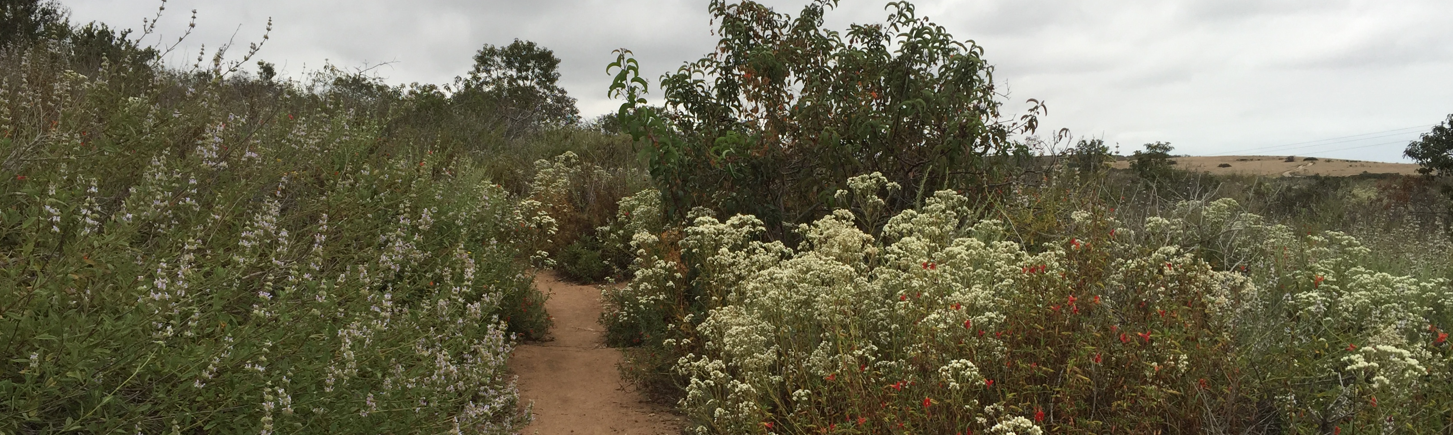
CA BIODIVERSITY DAY 2026
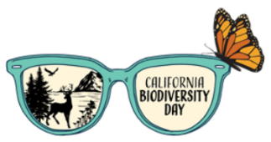


Join Preserve Calavera in coastal North San Diego County in celebrating the awesome biodiversity of our state through a number of in-person events over the week of Sept. 5-13. The official Biodiversity Day is Sept. 7th but we have too many great places to visit for 1 day. Many of our certified CA naturalists will be leading hikes.*
Sept.
Buddy Todd Park - birding
Lead:
2800 Mesa Dr, Oceanside, CA 92054
Bring binoculars

Before joining any of these events, become part of the iNaturalist bioblitz to record 30 species during the week. Create an iNaturalist account, then join the project:

Sept. 7, 6:15-8:30 pm, Whelan Lake Bird Sanctuary
Bat and Moth Celebration
Leads: Cindy Meyers, Janell Cannon, Karen Merrill*; pre-registration is required as space is limited.
3850 North River Rd, Oceanside, CA 92058
Bring headlamp/flashlight and bug spray.

Sept. 6, 10-11:45 am, Elfin Forest Recreational Reserve
Lead: Jon Sherman*; pre-registration is required as space is limited.
8833 Harmony Grove Road
Escondido, CA 92029
Stay for the Dryads at the Interpretative Center at noon.
Sept. 13, 10-noon, Batiquitos Ecological Reserve
Lead: David Newman*; meet at nature center
7380 Gabbiano Lane, Carlsbad 92011

For more information or to pre-register, contact Paige at pdecino@hotmail.com

